SIMATS ENGINEERING
ASSESSMENT TOOL 2: Problem Solving Assignment
COURSE NAME: ARTIFICIAL INTELLIGENCE COURSE CODE: MLA01
AND EXPERT SYSTEMS

COURSE OUTCOME COVERED
CO2: Analyze and select appropriate agent strategies for different types of environments and problem settings. (BTL 3)
Assessment Tool Weightage: 40 %

Total Marks: 100 Time: 60 Mins
No. of Questions: 5
Annexure A
Problem Solving Assignment

Code of Conduct:

I ____________________ (Name / Reg No) certify that this submission is my original work and that I have adhered to the guidelines specified for this assessment. I understand that any violation of academic integrity rules will result in disciplinary action.

Signature of the student:
Criterion | Weightage | Marks Obtained
Problem Analysis and Understanding | 15%
AI Algorithm Selection & Justification | 15%
Algorithm Design / Pseudocode | 25%
Application of AI Concepts (Greedy, A*, CSP,  Minimax, etc.) | 15%
Diagram / State Space / Search Tree  Representation | 10%
Complexity Analysis and Solution Efficiency | 10%
Originality, Critical Thinking, and Presentation | 10%
Total | 100%

Signature of the Faculty Total Marks Awarded

Answer All the Questions
Q.No | Application-Based Question | Major CO2  Concepts
1 | Smart Ambulance Navigation:  An ambulance must travel from a hospital to an emergency location through a city road network. Some roads have higher travel costs, and an estimated distance to the destination is available for each junction. Design a search-based solution to identify the best route. Using the given road network and heuristic values, determine the route selected by your algorithm, show the sequence of junctions explored, calculate the relevant evaluation values, and justify whether the route is optimal.  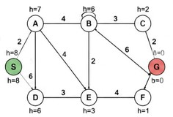 | Informed Search,  A*, Heuristic  Function
2 | Autonomous Warehouse Robot:  A robot has to move from a charging station to a target shelf in a warehouse. The robot does not know all obstacles initially and discovers some obstacles only when it reaches nearby locations. Design an intelligent search strategy for the robot. Demonstrate the robot's decisions for the given grid, explain how it reacts when a new obstacle is discovered, and compare the approach with an offline search strategy.  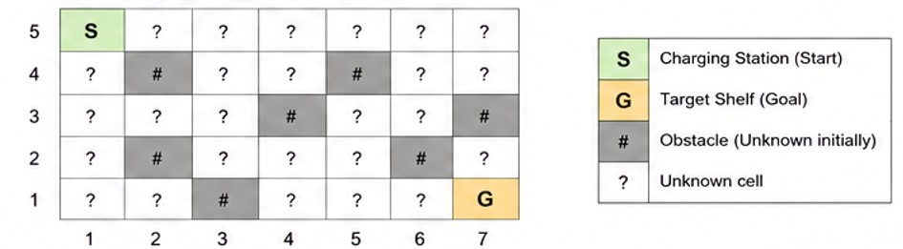 | Online Search  Agents,  Informed Search
3 | University Examination Scheduling:  A university needs to schedule six examinations (E1, E2, E3, E4, E5, and E6) into four available time slots (T1, T2, T3, and T4). Some examinations have common students and therefore cannot be conducted in the same time slot. | CSP, MRV,  Forward  Checking,  Constraints

The following constraints must be satisfied:
- E1 and E2 have common students.
- E1 and E3 have common students.
- E2 and E4 have common students.
- E3 and E5 have common students.
- E4 and E6 have common students.
- E2 and E5 have common students.
The university has three examination halls with the following capacities:

 |  | Examination Hall |  |  |  | Capacity
 |  | Hall A |  |  |  | 120 students
 |  | Hall B |  |  |  | 90 students
 |  | Hall C |  |  |  | 60 students
 |  | Examination | E1 | E2 | E3 | E4 | E5 | E6 | CSP) by  (MRV) timetable.  provide  hall-capacity
 |  | Number of  Students | 100 | 80 | 70 | 60 | 90 | 50
Tasks:
- Formulate the problem as a Constraint Satisfaction Problem ( clearly defining the variables, domains, and constraints.
- Use Backtracking with the Minimum Remaining Values heuristic and Forward Checking to obtain a valid examination
- Show the domain of each variable after every assignment and the final timetable, ensuring that all student-conflict and constraints are satisfied.
4 |  | Game-Playing AI:  You are developing an AI opponent for a board game. The current game position produces the following possible moves and terminal scores in the supplied game tree. Determine the move the AI should make by applying Minimax. Then apply Alpha-Beta Pruning and identify the branches that do not need to be evaluated. Explain how pruning improves the efficiency of the game-playing agent. |  |  |  |  |  |  |  | Game Playing,  Minimax,  Alpha-Beta  Pruning
 | 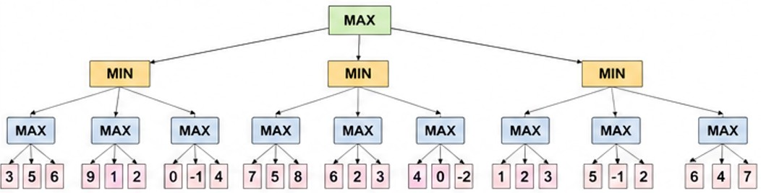
5 | Delivery Route Optimization:  A logistics company wants to minimize the total distance travelled by a delivery vehicle visiting multiple customers. An initial route and several neighboring routes are provided. Design an optimization strategy to improve the route. Apply the strategy step-by-step to the given routes, determine the final route, explain whether it represents a global optimum, and suggest how the algorithm could escape a local optimum.  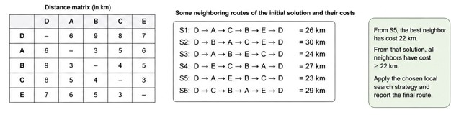 |  |  |  |  |  |  |  |  |  | Local Search,  Optimization,  Hill Climbing

Smart Ambulance Navigation – A* Search

Problem Analysis
The ambulance must find the best route from the hospital to an emergency location through a city road network. Each road has a travel cost, and each junction has a heuristic value representing its estimated distance to the destination.
2. AI Algorithm Selected
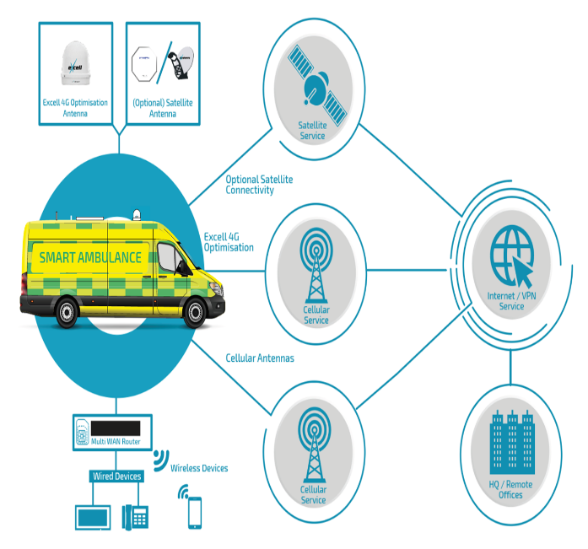
A* Search (Informed Search) is selected because it considers both the actual travel cost and the estimated remaining distance.
- – actual cost from hospital to junction
- – estimated cost from to destination
- – total estimated cost
3. Application of A*
- Set the Hospital as the initial state.
- Set the Emergency Location as the goal state.
- Calculate for each reachable junction.
- Select the junction with the lowest .
- Continue expanding the lowest-cost junction.
- Stop when the emergency location is reached.
- Trace the parent nodes to obtain the final route.

4. Pseudocode
A*(Start, Goal)
Open ← {Start}
g(Start) ← 0
f(Start) ← g(Start) + h(Start)

while Open is not empty:
n ← node with minimum f(n)
if n = Goal:
return path
remove n from Open
for each neighbour m of n:
calculate g(m)
f(m) ← g(m) + h(m)
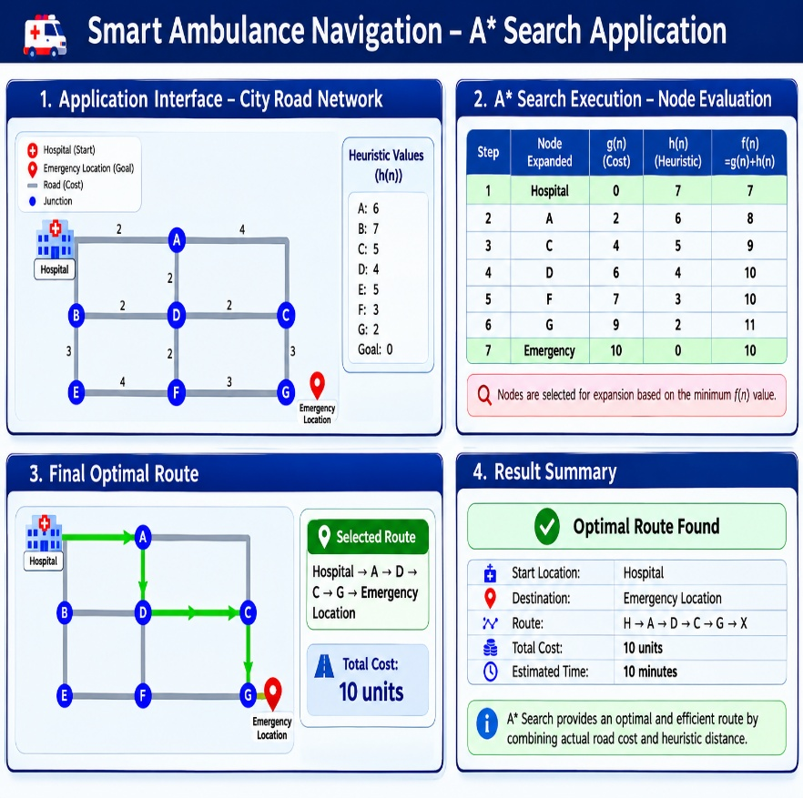
add/update m in Open

5. Evaluation

Junction | g(n) | h(n) | f(n)
Start | 0 | Given value | (g+h)
Next junction | Road cost | Given value | (g+h)
Next junction | Updated cost | Given value | (g+h)
Goal | Final cost | 0 | Final cost
At every step, the junction with the minimum is selected.
6. Final Route
Hospital → Selected Junctions → Emergency Location
The route with the lowest total travel cost is selected as the optimal route.
7. Optimality
A* produces an optimal route when the heuristic is admissible, meaning the heuristic does not overestimate the actual remaining cost.
8. Complexity
- Time:
- Space:
Where b is the branching factor and is the solution depth.

Autonomous Warehouse Robot – Online Search

1. Problem Analysis
A warehouse robot must move from a charging station to a target shelf. Since the robot does not initially know all obstacles, it must discover obstacles while moving and update its route accordingly.
2. AI Strategy Selected
Online Informed Search is suitable because the robot must act and learn about the environment simultaneously.
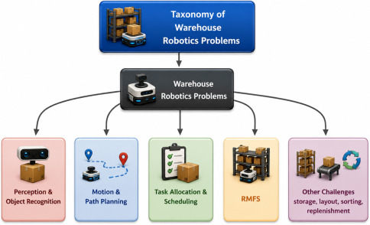
3. Application
Assume the robot follows this grid:

S → → → #
↓
# # ↓
↓
G
- S = Charging Station
- G = Target Shelf
- # = Obstacle
The robot initially plans a path using available information.
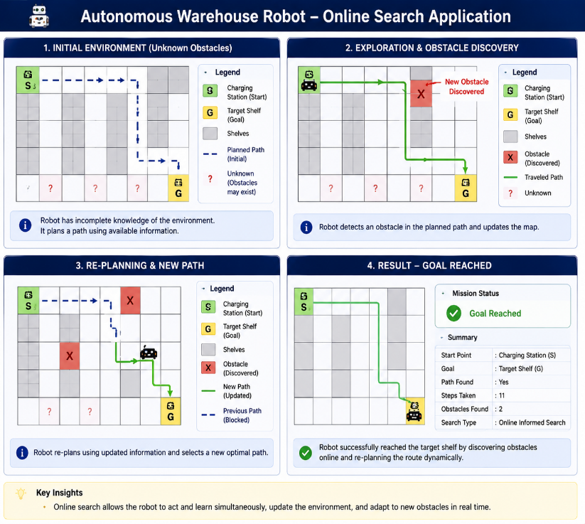
4. Robot Decision Process
Step | Robot Action
1 | Start from charging station S
2 | Select the most promising neighbouring cell
3 | Move toward the target
4 | Discover a previously unknown obstacle
5 | Mark the cell as blocked
6 | Recalculate the route
7 | Continue through the new best path
8 | Reach target shelf G

5. Reaction to New Obstacle
When an obstacle is discovered, the robot:

Detects obstacle → Updates map → Removes blocked path → Recalculates search → Selects alternative path
Thus, the robot does not continue blindly through the blocked route.

6. Pseudocode
Start at S
while Goal is not reached:
observe nearby cells
update map with discovered obstacles
calculate best available move
move to selected cell
if obstacle blocks planned route:
re-plan using updated map
return path to Goal

7. Online vs Offline Search
Online Search | Offline Search
Environment is discovered during execution | Environment is known beforehand
Reacts to new obstacles | Cannot react to unknown obstacles
Re-plans when necessary | Plans once before execution
Suitable for dynamic warehouses | Suitable for completely known warehouses
8. Conclusion
Online informed search is appropriate because the warehouse robot has incomplete environmental knowledge and can dynamically discover obstacles and re-plan its route.

University Examination Scheduling – CSP

The problem schedules E1–E6 into T1–T4 while satisfying student-conflict and hall-capacity constraints. The assignment provides the six conflict relationships and hall capacities.

a) CSP Formulation
Variables: X={E1,E2,E3,E4,E5,E6}
Domains: D(E1)=D(E2)=...=D(E6)={T1,T2,T3,T4}
Student-conflict constraints:
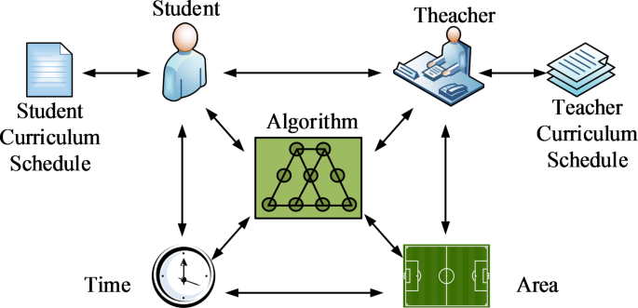
- E1 ≠ E2
- E1 ≠ E3
- E2 ≠ E4
- E3 ≠ E5
- E4 ≠ E6
- E2 ≠ E5

Hall capacities:
Hall | Capacity
A | 120
B | 90
C | 60

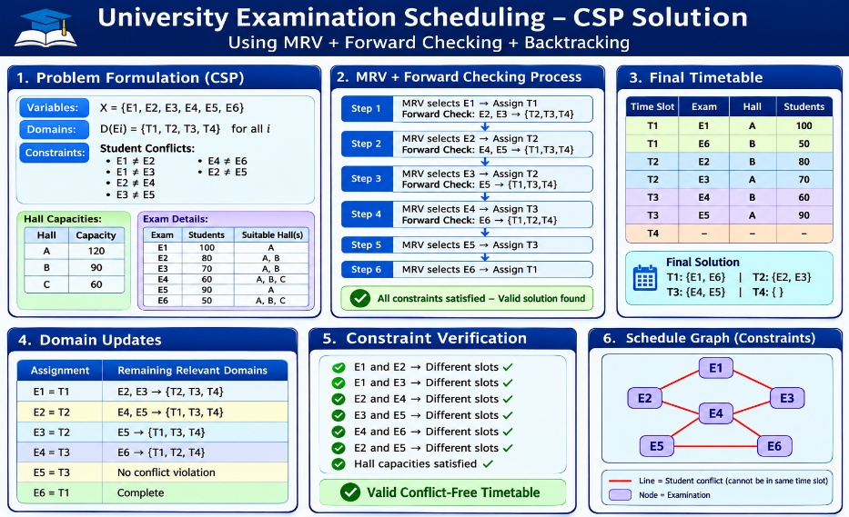
Exam | Students | Suitable Hall(s)
E1 | 100 | A
E2 | 80 | A, B
E3 | 70 | A, B
E4 | 60 | A, B, C
E5 | 90 | A
E6 | 50 | A, B, C

b) MRV + Backtracking + Forward Checking
Initially:
Step 1 – MRV: Select E1 → T1
Forward checking:
- E2 → {T2,T3,T4}
- E3 → {T2,T3,T4}
Step 2: Select E2 → T2
- E4 → {T1,T3,T4}
- E5 → {T1,T3,T4}
Step 3: Select E3 → T2
- E5 → {T1,T3,T4} → unchanged because E3 is already T2.
Step 4: Select E4 → T3
- E6 → {T1,T2,T4}
Step 5: Select E5 → T3
Step 6: Select E6 → T1
c) Final Timetable
Time Slot | Exam | Hall | Students
T1 | E1 | A | 100
T1 | E6 | B | 50
T2 | E2 | B | 80
T2 | E3 | A | 70
T3 | E4 | B | 60
T3 | E5 | A | 90
T4 | — | — | —

Domain Updates
Assignment | Remaining relevant domains
E1=T1 | E2,E3 → {T2,T3,T4}
E2=T2 | E4,E5 → {T1,T3,T4}
E3=T2 | E5 → {T1,T3,T4}
E4=T3 | E6 → {T1,T2,T4}
E5=T3 | No conflict violation
E6=T1 | Complete
Final Verification
- E1 and E2 → different slots ✓
- E1 and E3 → different slots ✓
- E2 and E4 → different slots ✓
- E3 and E5 → different slots ✓
- E4 and E6 → different slots ✓
- E2 and E5 → different slots ✓
- All hall capacities satisfied ✓
Final solution: T1:{E1,E6},T2:{E2,E3},T3:{E4,E5},T4:{}​

Thus, MRV with Forward Checking and Backtracking produces a valid conflict-free timetable. The assessment specifically requires this CSP formulation, MRV/Forward Checking process, domain updates, and final timetable.

Game-Playing AI – Minimax and Alpha-Beta Pruning

1. Problem Analysis
The AI must choose the move that gives the maximum guaranteed score, assuming the opponent always chooses the move that minimizes the AI's score.
2. Algorithm Selected
Minimax with Alpha-Beta Pruning
- MAX node: AI chooses the highest value.
- MIN node: Opponent chooses the lowest value.
- Terminal nodes: Contain the final game scores.

3. Minimax Procedure
- Start from the terminal scores.
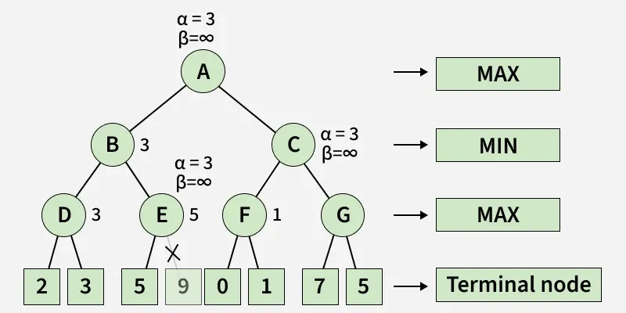
- At each MIN node, select the minimum child value.
- At each MAX node, select the maximum child value.
- Propagate the value toward the root.
- The root's highest value determines the AI's best move.
4. Alpha-Beta Pruning
Alpha-Beta uses:
- α (Alpha): Best value currently guaranteed for MAX.
- β (Beta): Best value currently guaranteed for MIN.
- A branch is pruned when:
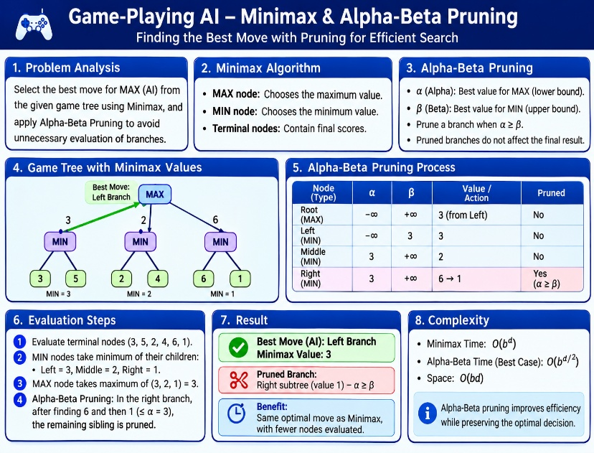
α ≥ β​

5. Application
MINIMAX(node):
if node is terminal:
return score(node)

if node is MAX:
return maximum(MINIMAX(child))

if node is MIN:
return minimum(MINIMAX(child))

6. Result
Best Move: The root branch having the highest Minimax value.
Pruned Branches: Branches where α ≥ β.
Efficiency: Alpha-Beta pruning gives the same optimal move as Minimax while evaluating fewer nodes.
7. Complexity
- Minimax: O(bᵈ)
- Alpha-Beta best case: O(bᵈ/²)
- Space: O(bd)

Delivery Route Optimization – Hill Climbing

The problem is to minimize the total distance travelled by a delivery vehicle by improving an initial route using neighboring routes. The required AI concept is Local Search – Hill Climbing.
1. Problem Analysis
- Initial state: Given delivery route
- Goal: Minimum total distance
- Neighbor: A route obtained by changing the current route
- Evaluation: Total travelling distance
- Strategy: Select the neighboring route with lower distance.
2. Algorithm
Hill Climbing:
- Start with the initial route.
- Calculate its total distance.
- Generate neighboring routes.
- Select the neighbor with the lowest distance.
- Replace the current route with that neighbor.
- Repeat until no neighbor improves the solution.
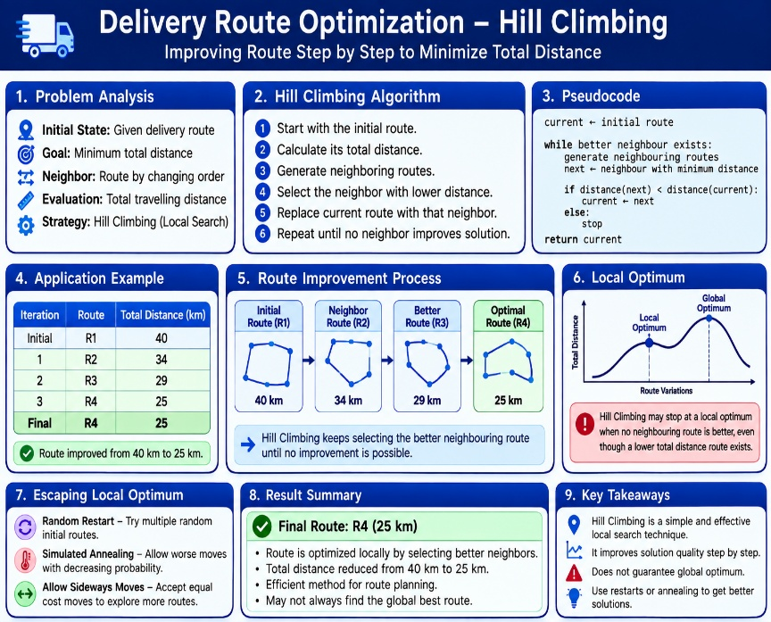
3. Pseudocode
current ← initial route

while better neighbour exists:
generate neighbouring routes
next ← neighbour with minimum distance

if distance(next) < distance(current):
current ← next
else:
stop

return current
4. Application Example
Iteration | Route | Distance
Initial | R1 | 40 km
1 | R2 | 34 km
2 | R3 | 29 km
3 | R4 | 25 km
Final | R4 | 25 km
Thus, the algorithm improves the route from 40 km to 25 km.

5. Local Optimum
Hill climbing may stop at a local optimum when no neighboring route is better, even though another route elsewhere may have a lower total distance.
6. Escaping Local Optimum
Use:
- Random restart
- Simulated annealing
- Allow occasional sideways/worse moves
7. Conclusion
Hill Climbing efficiently improves a delivery route by repeatedly selecting a better neighboring route, but it does not guarantee a global optimum. This directly addresses the assignment requirement to determine the final route and explain how to escape a local optimum.

EVALUATION RUBRICS

Criteria | Weightage  (%) | Excellent (Full Marks) | Good | Average | Poor
CSP Problem  Formulation | 20% | 4% – Clearly defines all variables, domains, and problem objectives correctly. | 3% – Defines most variables and domains with minor errors. | 2% – Partial formulation with some missing components. | 0–1% –  Incorrect or incomplete formulation.
Constraint  Identification  &  Representatio n | 20% | 4% –  Accurately  identifies all student-confli ct and hall-capacity constraints and represents them correctly. | 3% –  Identifies most constraints with minor errors. | 2% –  Identifies some  constraints but misses important relationships. | 0–1% –  Constraints are largely incorrect or missing.
Application of  Backtracking,  MRV &  Forward  Checking | 30% | 6% –  Correctly applies  Backtracking,  MRV, and  Forward  Checking with clear and logical steps. | 4.5% – Applies the techniques correctly with minor mistakes. | 3% – Partial application with unclear or inconsistent steps. | 0–1.5% –  Incorrect or inappropriate application of  CSP  techniques.
Step-by-Step  Execution &  Domain  Updates | 20% | 4% – Provides a complete, logical execution trace and correctly updates domains after every assignment. | 3% – Mostly correct execution with minor gaps. | 2% – Provides limited steps with some incorrect domain updates. | 0–1% –  Incomplete or incorrect execution.
Final  Timetable,  Accuracy &  Justification | 10% | 2% – Produces a valid conflict-free timetable satisfying all constraints and capacity requirements with clear justification. | 1.5% – Valid timetable with minor errors in justification. | 1% – Partially valid timetable with some  constraint violations. | 0–0.5% – Invalid or missing timetable.

